Software Design Document

Software Name：Medi-Care

# **Part1 Introduction**

Medi-Care App is a mobile application for people who need to take medication regularly. It aims to help users take medication on time and gradually cultivate good habits of health management through efficient medication reminder and diagnosis management functions. In modern society, due to the busy work or fast pace of life, many people often forget to take medicine on time, especially users with chronic diseases or in need of long-term treatment, which will adversely affect the treatment effect. The development of this software is based on the health needs of users, through simple and friendly interface design and efficient functional support, to provide users with medication reminder and medical record services.

The software is suitable for a wide range of scenarios, including daily medication reminders, chronic disease management, and consultation records query and tracking. With the help of modern mobile Internet technology and cloud services, the application not only improves the medication experience, but also pays attention to data synchronization and privacy protection, providing users with a safe and reliable health management tool.

# **Part2 Requirements Specification**

The Medi-Care application is designed to cater to diverse user groups, including parents managing family medications at home, students requiring discreet reminders during school, and individuals who need timely medication intake, such as fitness enthusiasts taking supplements or chronic disease patients adhering to strict schedules. These user groups share a need for a reliable system to organize, schedule, and track their medication intake effectively, ensuring no doses are missed. The application must allow users to add medications, set reminders, and customize notification preferences based on their daily routines. Seamless data synchronization across multiple devices is essential, enabling users to manage their schedules from anywhere, while cloud backup ensures data security and prevents loss.

**Parents managing family medications** require features to organize medications for multiple family members within one account. Separate profiles or tags for each family member allow for better organization and differentiation of medication schedules. Additionally, a virtual medicine cabinet feature is essential, offering stock tracking and expiration date reminders to ensure the availability of necessary medications. **For students**, the app needs to provide discreet notification options to avoid disruptions during classes or exams and flexible scheduling to accommodate varying routines such as class times and extracurricular activities.

**Fitness enthusiasts** benefit from the ability to manage both dietary supplements and regular medications within a single app. The application should support setting reminders for non-traditional schedules, such as pre-workout or post-workout supplement intake. Meanwhile, **chronic disease patients** rely heavily on accurate and timely reminders to adhere to medication schedules. The app should also provide detailed logs of medication history, which can be shared with healthcare providers during consultations.

Based on the analysis of user group needs, the functional requirements of the application are designed to ensure a seamless and user-friendly experience. The **interface should be simple, intuitive, and visually appealing**, with features logically distributed to allow users of all technical skill levels to navigate and utilize the app effortlessly. To facilitate smooth execution of core functions, the application should provide clear operational instructions and responsive interaction feedback, enhancing user satisfaction and confidence in the system.

**A robust user data management system** is essential, supporting fundamental operations such as creating, reading, updating, and deleting medication and profile data. The system should include synchronization services that ensure data consistency between local storage and the cloud, providing a reliable backup solution and enabling users to switch devices without losing their information. Offline mode support is critical for uninterrupted access, allowing users to manage and view their medication schedules even without an active internet connection.

Additionally, the app should feature **multi-device compatibility,** ensuring users can log in from various devices, such as smartphones, tablets, or other platforms, with their data fully restored and synchronized. Other key functionalities should include batch data input options to simplify the addition of multiple medications, personalized notification settings for reminders, and real-time alerts to ensure users never miss a dose. These functional requirements aim to create a comprehensive, efficient, and accessible medication management solution for all user groups.

# **Part3 Overall Design**

The Medi-Care App is built on a client-cloud architecture to provide a seamless and efficient user experience. The client side handles core functionalities such as user interface interactions, medication reminders, and medical record management. Meanwhile, the cloud server ensures secure storage of user data and supports multi-device synchronization, enabling users to access their information from any device effortlessly.

The application is structured into several key modules, each designed to address specific user needs:

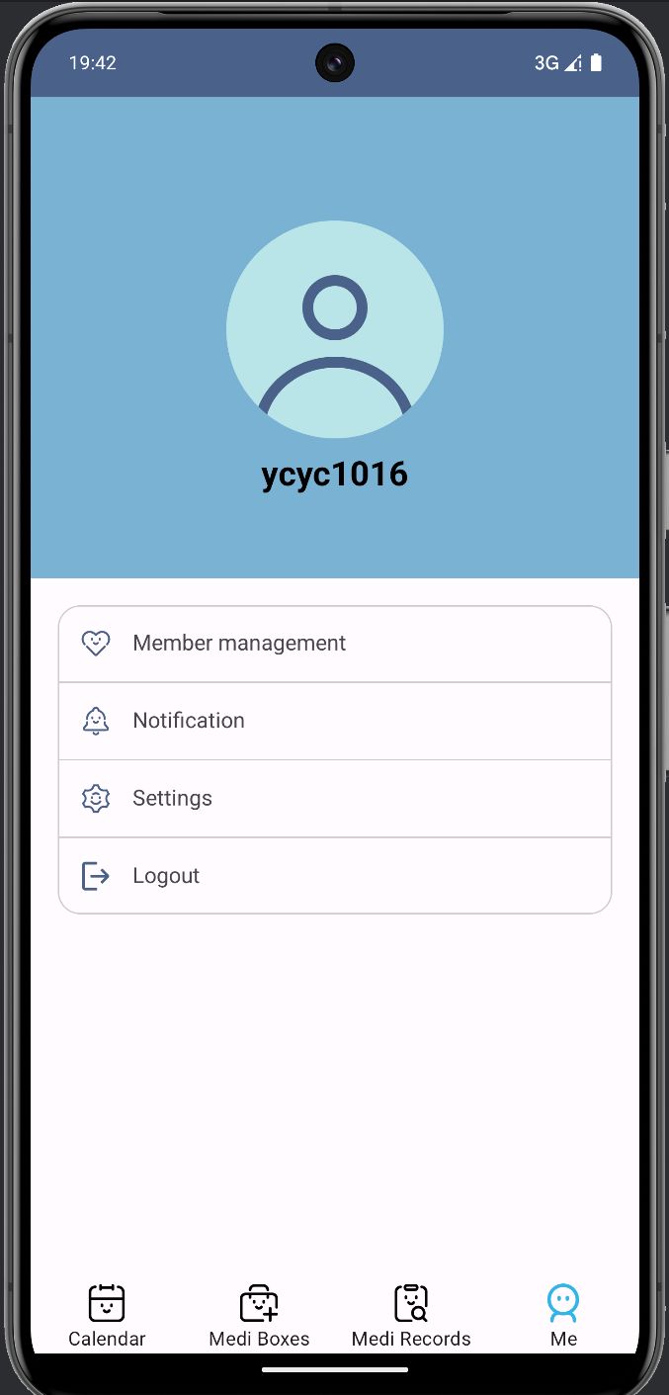

**User Page**

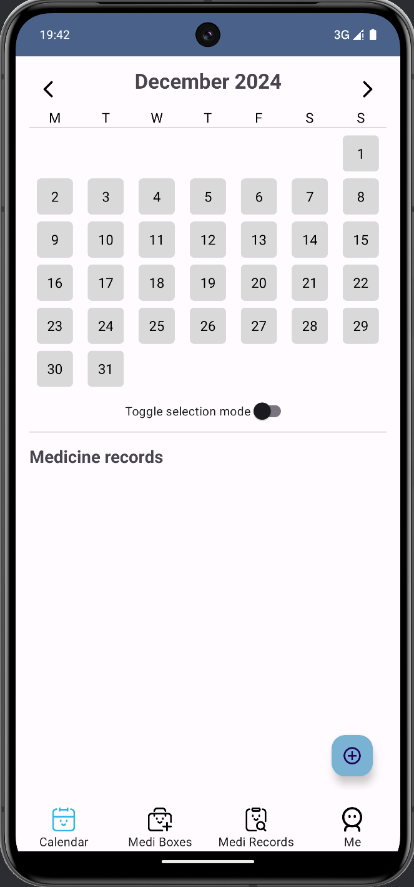

**Calendar Page**

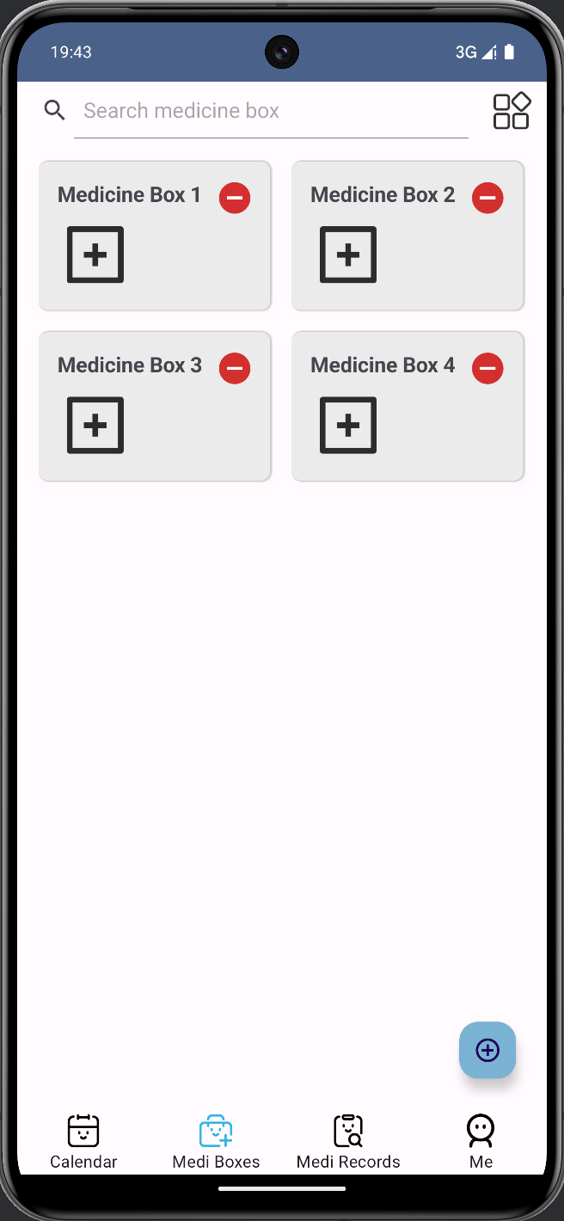

**Box Page**

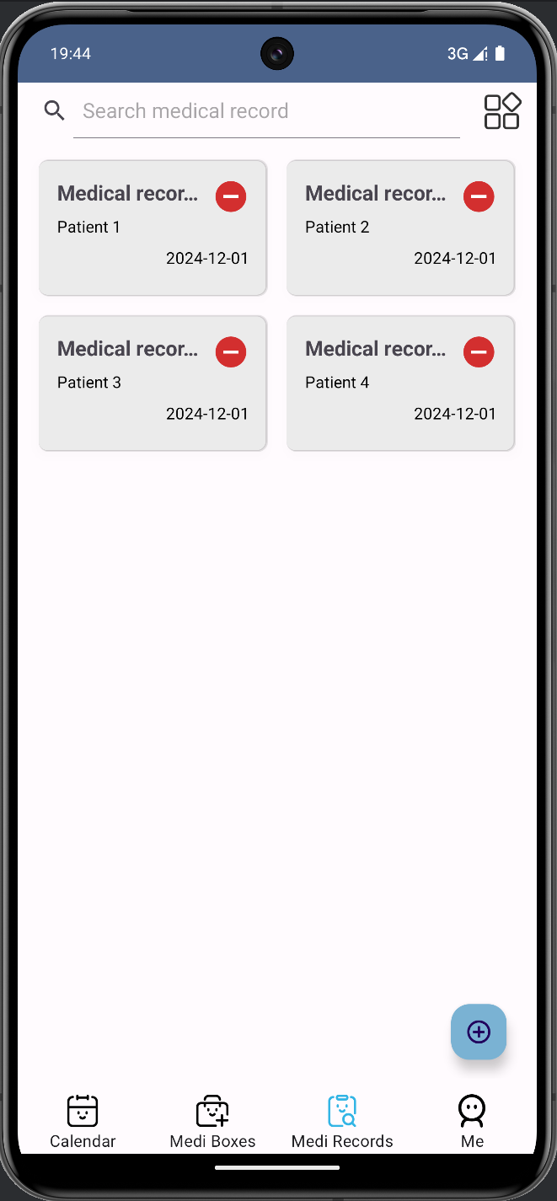

**Record Page**

* **User Module:** This module manages user registration, login, and account-related tasks. It ensures secure access to the application and supports account customization for a personalized experience.
* **Calendar Module:** Central to the app's functionality, the calendar module allows users to add, modify, and view medication schedules. Through an intuitive calendar interface, users can manage their medication plans with ease and set reminders for timely intake.
* **Medical Box Module:** This module helps users organize and manage their medications by allowing them to sort medicines based on conditions, target users, or other criteria. Additionally, users can record details about their physical medicine boxes, such as location and appearance, making storage and retrieval more convenient.
* **Medical Record Module:** It enables the input, viewing, and editing of medical record information and also supports the association and binding with medication information.
* **Notification Module:** Dedicated to ensuring users never miss a dose, this module generates and sends medication reminders. Users can choose between system notifications and the app’s built-in alarm clock for flexible and reliable reminder options.

# **Part4 User Interface Design**

The Medi-Care App's user interface design is centered around two essential concepts: "simplicity" and "a sense of health", with a significant emphasis on optimizing the user experience and maintaining consistency in visual design. The overall color palette of the interface features a gentle blue gradient as the dominant hue, complemented by white and gray as secondary colors. This combination works together to evoke a feeling of health, freshness, and reassurance.

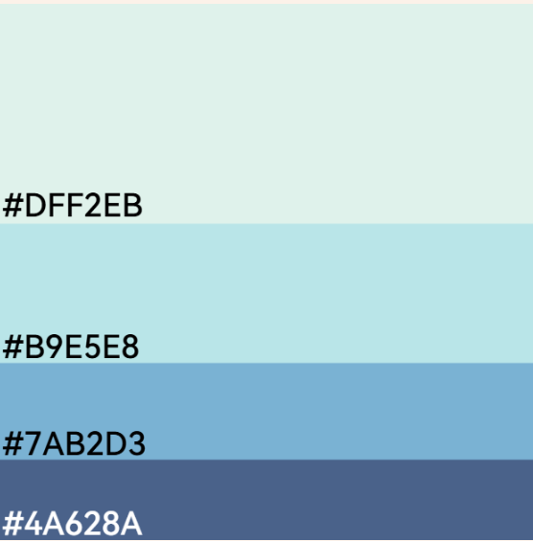

**Colors**

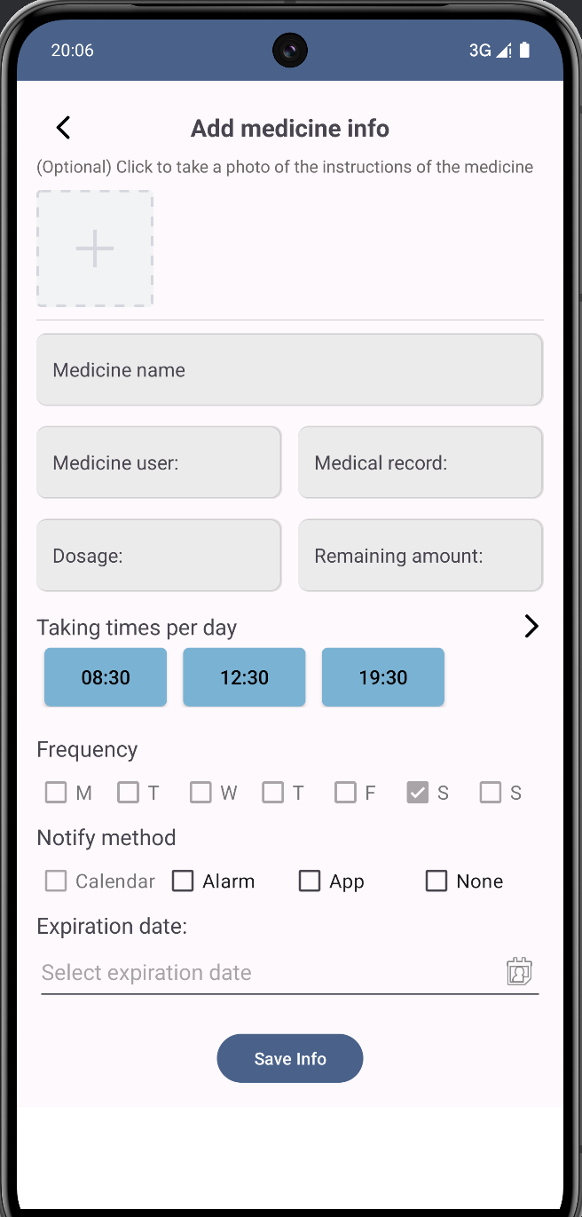

**Add Medication**

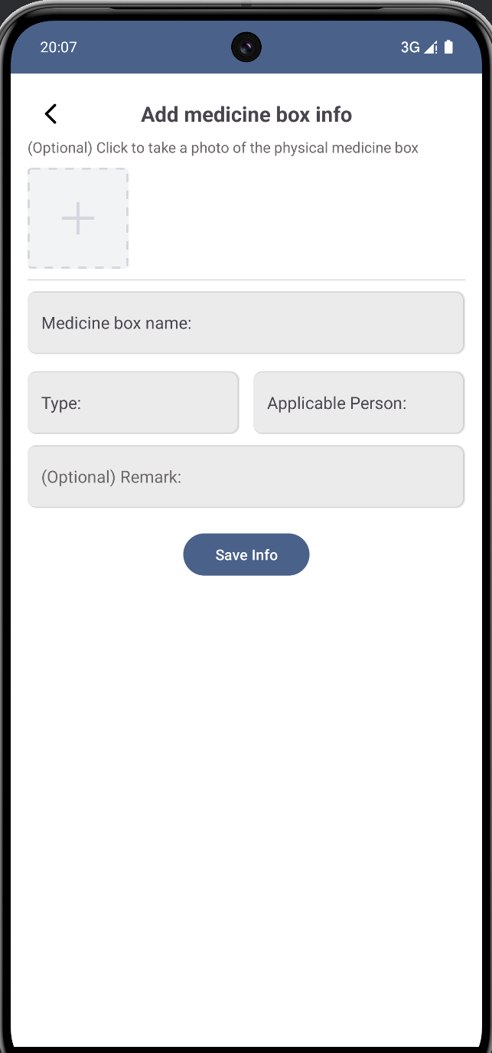

**Add Box**

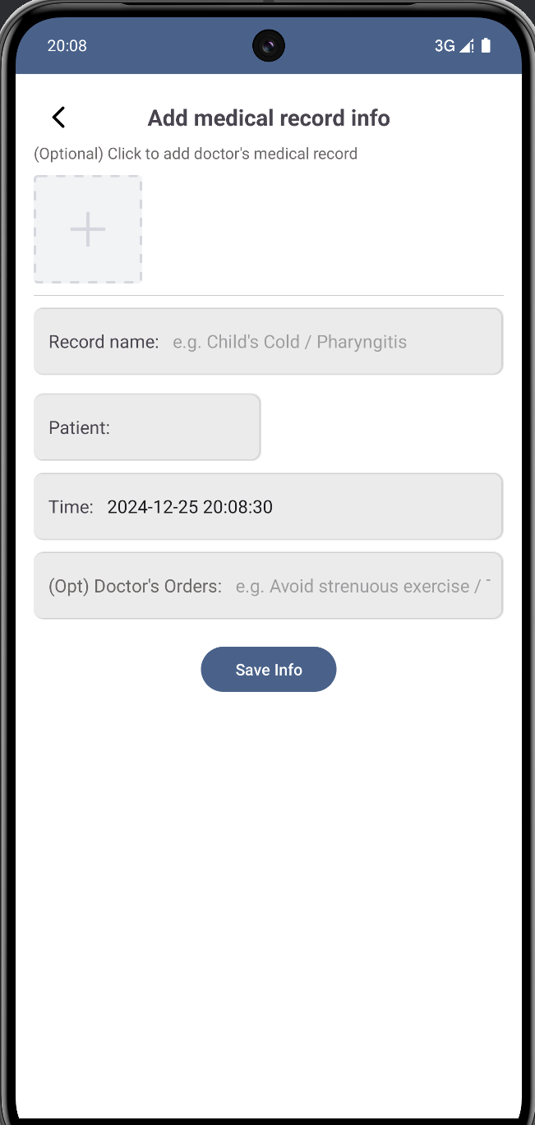

**Add Record**

The user page, which encompasses login, registration, and account information display, is designed to be clear and uncluttered. The form validation interactions are both prompt and user-friendly. The calendar page utilizes an intuitive calendar view that permits single and multiple date selection operations. Users can effortlessly view, add, or modify their medication plans. When a specific date is clicked, a details box pops up, presenting the medication information for that particular day. The medical record page offers a categorized list of medical record entries and supports a search function. This enables users to swiftly locate and update their medical record information and also review the associated medication records.

In each addition page, the detailed information to be filled in is displayed. In order to ensure the accurate filling of the information, appropriate interactions are set in the information filling, such as: trigger reminder when the information is filled in and completed.

In terms of interaction design, buttons have dynamic feedback, such as color changes or a slight enlargement effect, when clicked. Real-time prompts are provided during form filling to minimize operational errors. Page transitions are enhanced with transition animations, which contribute to a smoother and more aesthetically pleasing experience.

# **Part5 Key Technologies**

The Medi-Care app based on the Android platform integrates a variety of technologies, from front-end to back-end, to ensure efficient functionality, good user experience, and reliable data management. Below is the key technologies used in this software:

* **Material Design 3** is used to ensure a modern, consistent, and intuitive user interface, providing a clean layout across the app.
* **ViewPager2 with RadioGroup** enables smooth navigation between key sections, such as the Calendar, Medical Box, and Medical Records, allowing users to switch seamlessly through swipe gestures or buttons.
* **Resources** are employed to manage assets like strings, images, and layouts, ensuring the app adapts to different screen sizes and languages, maintaining a consistent experience across devices.
* **AlarmManager** is crucial for scheduling medication reminders, triggering notifications or alarms at specified times to ensure users never miss their doses.
* **Room** simplifies local data management by offering an abstraction layer over SQLite, enabling efficient storage of user data, medication schedules, and preferences, even without internet connectivity.
* **Retrofit** is employed for network communication between the client and cloud server. It handles API requests and responses, enabling the app to synchronize data between the local database and cloud storage. Retrofit simplifies the process of interacting with RESTful web services and ensures that data is efficiently transmitted, ensuring users’ medication records are always up-to-date across devices.
* **SQLite** is the embedded database that stores structured data locally on the device. It manages data like medication records, user details, and settings. SQLite is a lightweight, fast, and reliable solution for offline storage, ensuring that the app can function seamlessly even without network connectivity.
* **Sync Adapter** facilitates background synchronization between the local database and cloud server, ensuring that user data remains consistently updated across all devices, even when the app is not in use.

However, there are also technical challenges and corresponding solutions. For screen adaptation, the layout and dynamic size adjustment are adopted to address the layout issues caused by different screen resolutions. In terms of key functionalities, the app's core logic handles relationships between various types of data, such as user profiles, medication records, and medical history. For example, medication reminders are linked to the calendar, and medical records are associated with corresponding medication information. The system ensures that updates to any of these records are reflected in real-time across different parts of the app. Regarding data synchronization, a time-stamp-based synchronization mechanism is designed to prevent conflicts between local and cloud data and also ensure the security of data transmission. This combination of technologies and solutions enables the app to function smoothly and provide a reliable user experience.

# **Part6 Testing and User Experience Analysis**

To ensure the app's compatibility and performance across various devices, we conducted comprehensive tests using Tencent's WeTest platform, covering the Top 50 mainstream devices. The results showed good overall compatibility, with a pass rate of 86%. The devices that failed the test included OPPO A83, MI 5X, Mi Note 3, vivo X9Plus, and OPPO R9s Plus. The primary reason for these failures was that their system SDK versions were lower than the app's minimum requirement (SDK 26). Since our app leverages advanced features and controls from newer SDKs, such as Material Design 3 components, these devices could not fully support the app's functionality. In future updates, we plan to improve compatibility for these devices by incorporating backward-compatible controls or alternative implementations to expand device support.

Analyzing the performance test reports from WeTest revealed strong performance across several key metrics:

* **Installation and Startup Time:** The app demonstrated short installation and startup times, reflecting its lightweight design and meeting user expectations for fast usability.
* **CPU Usage:** It exhibited low CPU utilization, indicating efficient processing and minimal background tasks.
* **Memory Usage:** Memory usage varied significantly across devices, likely due to differences in hardware configurations, system versions, and potential memory leaks in the app.
* **FPS:** The app consumed minimal data during synchronization and notifications, meeting the standards for a data-efficient application. The frame rate remained stable across test devices, ensuring smooth animations and interactions without noticeable lag.

Overall, the test results highlight the app's strengths in functionality and performance design, though some areas require optimization. In future iterations, we will focus on improving memory management, enhancing compatibility with older SDK versions, and refining startup speed and background processes to ensure stability and efficiency across a wider range of devices.

The user experience of the app has both strengths and weaknesses. On the positive side, the app offers several well-designed features that significantly enhance the user experience.

* + **User-Friendly Interface:** Its user-friendly interface, characterized by simple and clear layouts, along with visually appealing design and intuitive navigation, makes it easy for users to interact with the app.
  + **Valuable Functions:** Features like expiration reminders and family medication tracking are especially valued, as they address key user needs related to health management, enabling users to effectively manage their own medications and their family’s health.
  + **Cloud Backup:** The convenient cloud backup function provides users with peace of mind by ensuring the security of their data, which contributes to a positive overall experience.

However, the app also has areas that require improvement.

* + **Performance Issues:** Users have reported performance issues, such as lag when loading medication information, which undermines their experience.
  + **Complex Add Medication Process:** The process of adding medication information has been criticized for being overly complex.
  + **Lack of Onboarding Tutorials:** The absence of tutorials for new users creates a steep learning curve.

Possible solutions of them are:

* + **Optimizing database queries and improving network request efficiency**
  + **Add medication by scan the product code of it:** If it is possible to build a database of drug codes and drug information, this can be a good solution.
  + **Add use tutorial:** Introducing an onboarding tutorial or help section would assist users in understanding and utilizing the app effectively.

# **Part7 Conclusion**

The Medi-Care App has successfully achieved the goal of helping users take medication on time and pay attention to their own health by integrating medication reminder, clinic registration management and data synchronization functions. The development process overcomes the technical difficulties such as multi-screen adaptation and database synchronization, and finally provides an easy to use, reliable and featurely-rich mobile application.

In the future, the software plans to further optimize user privacy protection and add health data analysis and intelligent recommendations to help users manage their health more comprehensively.